

**Tribhuvan University**

**Faculty of Humanities and Social Sciences**

**A Project Report On**

**Galaicha Nepal E-commerce Platform**

**Submitted to**

**Department of Computer Application**

**National Integrated College**

##### In partial fulfillment of the requirements of Bachelors in Computer Application

Submitted by

Paban Kandel

Aman Raj Bhattarai

Under the supervision of:

Sandip Shrestha



**Tribhuvan University**

**Faculty of Humanities and Social Sciences National Integrated College**

## Supervisor’s Recommendation

I hereby recommend that this project prepared under my supervision by **Paban Kandel and Aman Raj Bhattarai** entitled “**Galaicha Nepal E-commerce Platform**” in partial fulfillment of the requirements for the degree of Bachelor of Computer Application is recommended for the final evaluation.

......................…

**SIGNATURE**

Mr. SandipShrestha

Bachelors in Computer Application National Integrated College, Dillibazar



**Tribhuvan University**

**Faculty of Humanities and Social Sciences Kathmandu Shiksha Campus**

# LETTER OF APPROVAL

This is to certify that this project prepared by **“Paban Kandel and Aman Raj Bhattarai”** entitled **“Galaicha Nepal E-commerce Platform”** in partial fulfillment of the requirements for the degree of Bachelor in Computer Application has been evaluated. In our opinion it is satisfactory in the scope and quality as a project for the required degree.

|  |  |
| --- | --- |
| *Signature of Supervisor* | *Signature of HOD* |
| *Signature of Internal Examiner*  **Internal Examiner** | *Signature of External Examiner*  **External Examiner** |

# ABSTRACT

The Galaicha Nepal E-commerce Platform aims to revolutionize the way floor mattresses are bought and sold in Nepal by introducing an innovative online marketplace. This project seeks to address the growing demand for quality sleep solutions in Nepal's evolving market landscape through the convenience of e-commerce. By leveraging sophisticated computer software and user-friendly interfaces, the platform aims to automate and streamline the current manual processes associated with purchasing floor mattresses.

The primary objective of the Galaicha Nepal E-commerce Platform is to provide users with a seamless shopping experience while ensuring the long-term storage and accessibility of essential data and information. Users will be able to browse a diverse selection of floor mattresses, including traditional Galaicha and modern alternatives, tailored to their preferences and requirements. The system will facilitate transactions, track orders, manage customer information, and store delivery addresses securely.

Key features of our platform include a user-friendly interface for browsing and purchasing mattresses, a comprehensive database for managing product listings and customer information, and secure payment processing capabilities. The platform is built using HTML and CSS for design, PHP for backend development, SQL for database management, and AJAX and jQuery for connecting pages during the payment gateway process. The system will be accessible to both customers and administrators, with built-in security measures to safeguard sensitive data.

By centralizing and automating the process of floor mattress procurement, the Galaicha Nepal E-commerce Platform aims to enhance efficiency, reduce manual workload, and improve overall customer satisfaction. This project contributes to the growth of Nepal's e-commerce sector while providing consumers with access to high-quality sleep products that meet their needs and preferences.with access to high-quality sleep products that meet their needs and preferences

# ACKNOWLEDGMENT

We are pleased to present this report on the Galaicha Nepal E-commerce Platform, a culmination of dedicated effort and collaboration. Our gratitude extends to all those who have contributed to the realization of this project.

First and foremost, we express our heartfelt appreciation to National Integrated College and our esteemed teacher for their invaluable support and guidance. Their encouragement and mentorship have been instrumental in guiding us through the complexities of this endeavor and providing us with the opportunity to apply theoretical knowledge in a practical setting. We extend our special thanks to all individuals who generously shared their expertise, time, and insights, enabling us to overcome challenges and make informed decisions throughout the development process. Their contributions have enriched the project and strengthened its foundation. Furthermore, we are grateful to our team members for their unwavering commitment, cooperation, and perseverance. Their dedication and collective effort have been pivotal in achieving our goals and delivering a high-quality outcome.

In conclusion, we acknowledge with deep appreciation the collaborative spirit and collective efforts of all those involved in this project. It is their support and encouragement that have propelled us forward and made this endeavor a success.

**Prepared by**

**Paban Kandel**

**Aman Raj Bhattarai**

**Bachelors of Computer Application National Integrated College**

## Table of Contents

**Supervisor’s Recommendation** **i**

**Letter of Approval** **.ii**

**Abstract** **….iii**

**Acknowledgment** **iv**

**Table** **of Contents** **.v**

**List of Abbreviations** **vi**

**List of Figures ………**………………...……………………………………………..**.vii**

**List of Tables…………………………………………………………………………viii**

**Chapter 1: Introduction 1**

1.2 Problem Statement 2

1.3 Objectives 3

1.4 Scope and limitation 3

1.5. Report Organization 5

**Chapter 2: Background Study and Literature Review…**……………….….……...…7

2.1 Background Study 7

2.2 Literature Review 7

**Chapter 3: System Analysis and Design 10**

3.1 System Analysis 10

3.2 System Design 17

**Chapter 4: Implementation and Testing 20**

4.1 Implementation 20

4.2 Testing 23

**Chapter 5. Conclusion and Future Recommendation 28**

5.1 Lesson Learnt/Outcome 28

5.2 Conclusion 28

5.3 Future recommendations 29

**REFERENCE………………………………………………………………..……….30**

**APENDIX…………………………………………………………………………… 31**

|  |  |
| --- | --- |
|  | **LIST OF ABBREVIATIONS** |
| **CASE** | Computer-Aided Software Engineering |
| **CSS** | Cascading Style Sheet |
| **DFD** | Data Flow Diagram |
| **ER** | Entity Relationship |
| **HTML** | Hypertext Markup Languages |
| **ICT** | Information and Communications Technology |
| **JS** | JavaScript |
| **LAN** | Local Area Network |
| **MYSQL** | My Structured Query Language |
| **PDA** | Personal Digital Assistant |
| **PHP** | Hypertext Preprocessor |
| **SQL** | Structured Query Languages |
| **TAM** | Technology Acceptance Model |

## List of Figures

Figure 3.1 Use case diagram of user and admin……………………………………..12

Figure 3.2: ER-Diagram………………………………………………………………15

Figure 3.3: DFD Level 0………………………………………………………………...16

Figure 3.4 : DFD Level 1…………………………………………………………….16

Figure 3.5: System Design……………………………………………………………..17

Figure 3.6: Architectural Design……………………………………………………….17

Figure 3.7: Database Schema Design………………………………………………..18

Figure 3.8: Physical DFD……………………………………………………………….19

## List of Tables

Table 4.1 : User AuthenticationTest...............................................................................25

Table 4.2 : Galaichas Display Module Test……………………………………………25

Table 4.3 Order placement module Test……………………………………………....26

Table 4.4 : Admin Dashboard ModuleTest…………………………………………….26

Table 4.5 End-to-End Order Placement test……………………………………………27

Table 4.6 : User Authentication test for system testing………………………………...28

* 1. **Introduction**

## Chapter 1: Introduction

A In today's digital era, the ease and convenience of online platforms have transformed the way we shop for various products, including household essentials. The traditional approach to purchasing Galaicha, traditional Nepali mattresses, is evolving with the advent of innovative e-commerce solutions. The Galaicha E-commerce Platform is a testament to this evolution, offering users a seamless and efficient way to explore, select, and purchase mattresses tailored to their preferences.

At the heart of the Galaicha E-commerce Platform is a user-centric approach, allowing customers to sign up or log in to the website to access a wide range of mattress options. With intuitive navigation and user-friendly interfaces, customers can easily browse through product listings, view detailed descriptions, and place orders with just a few clicks.The platform empowers both users and administrators with robust functionalities. Additionally, users can browse through the catalog of mattresses, compare features, and select the product that best suits their needs.Administrators, on the other hand, have comprehensive control over the platform's backend operations. Using PHP as the primary programming language for backend development, administrators can upload new mattress products, edit existing listings, and manage user accounts with ease. The integration of MySQL ensures efficient database management, allowing for seamless storage and retrieval of user and product information.

Key features of the Galaicha E-commerce Platform include secure user authentication, smooth order processing, and real-time inventory management. Users can track the status of their orders.. Furthermore, the platform offers a responsive design, ensuring a seamless browsing experience across devices.

In summary, the Galaicha E-commerce Platform represents a significant leap forward in the way mattresses are bought and sold in Nepal. By leveraging the power of technology and catering to modern consumer preferences, the platform aims to provide a convenient, transparent, and reliable shopping experience for users while empowering administrators with efficient backend management tools.

### Problem Statement

In Nepal, purchasing a Galaicha (floor mattress) has historically presented numerous challenges for consumers, contributing to a sense of inconvenience and frustration. One significant hurdle is the limited selection available in physical stores. Due to space constraints, retailers often have a restricted inventory on display, leaving customers with limited options to choose from. Additionally, the traditional method of visiting multiple stores to find the perfect Galaicha can be incredibly time-consuming, further adding to the inconvenience faced by buyers. Moreover, transportation issues exacerbate the purchasing process, as acquiring a Galaicha from a physical store often entails arranging for transportation, which can be both inconvenient and costly for customers.

Recognizing these challenges, Galaicha Nepal seeks to revolutionize the mattress shopping experience by offering a convenient, accessible, and hassle-free solution. Through our online platform, customers have access to an extensive selection of Galaicha options, eliminating the limitations imposed by physical store spaces. With just a few clicks, customers can browse through a diverse range of Galaicha products, compare features, and select the perfect mattress that meets their needs and preferences. By transcending geographical barriers and time constraints, Galaicha Nepal streamlines the purchasing process, making it easier and more convenient for customers to find their ideal Galaicha from the comfort of their own homes. Additionally, our platform eliminates the need for transportation arrangements, as we offer doorstep delivery services, ensuring a seamless and stress-free shopping experience for our valued customers

### Objectives

* To develop and launch an intuitive and user-friendly e-commerce platform for Galaichas in Nepal, facilitating a seamless online shopping experience that meets the unique needs and preferences of Nepali consumers, thereby increasing online sales and market reach.
* o integrate advanced technological features such as secure payment gateways, and efficient logistics management into the Galaicha E-commerce Website, enhancing operational efficiency and customer satisfaction while preserving and promoting the cultural significance of Galaichas.

#### Scopes

#### Scope of the Galaicha E-commerce Platform:

#### Enhanced Accessibility: The Galaicha E-commerce Platform revolutionizes the mattress shopping experience by providing easy access to a wide range of floor mattresses.

#### Tailored Selections: With a diverse array of Galaicha options available, the platform caters to individual preferences, styles, and needs.

#### Cost-Effective Solutions: By operating online, Galaicha vendors can significantly reduce overhead costs typically associated with maintaining brick-and-mortar stores. This cost efficiency enables vendors to offer competitive pricing to customers while maintaining quality standards, ensuring a win-win situation for both parties.

#### Flexible Expansion: The Galaicha E-commerce Platform offers vendors the flexibility to expand their product offerings and reach a broader audience without the constraints of physical space.

#### Insightful Analytics: Leveraging digital operations, the platform gathers valuable data on customer preferences, purchasing behaviors, and market trends.

#### Limitation

The Galaicha E-commerce Platform, while offering numerous advantages, also presents certain limitations that require attention and resolution. Acknowledging these limitations is essential for ensuring the platform's continuous improvement and effectiveness. Some notable limitations include:

* **Shipping Constraints**: Shipping bulky items like Galaicha may lead to delays or increased costs, particularly for deliveries to remote areas. Overcoming these challenges requires strategic planning and collaboration with reliable shipping partners to optimize logistics and minimize disruptions.
* **Online Representation Challenges**: Accurately representing Galaicha texture and color online can be challenging due to variations in screen resolutions and lighting conditions. Implementing high-quality images, detailed descriptions, and virtual try-on features can help mitigate discrepancies and provide customers with a more accurate depiction of the product.
* **Returns Complexity**: Handling returns for large items like Galaicha can be complex and costly, involving logistics, restocking, and potential damage assessments. Developing clear and transparent return policies, along with efficient return processes, is essential for managing customer expectations and minimizing operational challenges.
* **Technical Maintenance Requirements:** Maintaining and updating the Galaicha E-commerce Platform requires technical expertise and resources. Regular maintenance, security updates, and software upgrades are essential to ensure the platform's functionality, reliability, and security. Investing in skilled personnel and robust infrastructure is crucial for addressing technical challenges and ensuring seamless platform operation.

### 1.5. Report Organization

The internship report consists of four chapters altogether. The report has been organized in the order given below:

**Chapter 1: Introduction**

The first part of the report contains the summarized introduction of the whole report. It includes the overview, scope and limitation, problem statement and objectives of this project.

**Chapter 2: Background Study and Literature Review**

The second chapter includes background study i.e. description of fundamental theories, general concepts and terminology related to the project. It also includes the literature review i.e. review of the similar projects, research and theories done by other researchers.

**Chapter 3: System Analysis and Design**

The third chapter includes the system analysis and design phase in which the report of functional and non-functional requirements of the project is stated using use case and system diagrams. It also includes the feasibility study about the system which explains whether the system development process is affordable and within the knowledge range of the developers. It shows the technical, operational and economic feasibility of the project development phase. The explanation of the designing of the system is also done in this chapter. It includes data modeling and process modeling which is explained by using ER diagram and Data Flow Diagram. The architectural design, database design and the user interface design is also listed in this chapter.

**Chapter 4: Implementation and Testing**

The fourth chapter includes the implementation and testing phase of the proposed system. In the implementation phase, tools like CASE tools, programming languages and database platforms are implemented.

**Chapter 5: Conclusion and Learning Outcomes**

The fifth chapter includes conclusion and future recommendation. This contains the final paragraphs of the report and in this phase the overall outcome and the developer’s point of view is written. The lesson that I learned through all the phases can also be included in this phase.

**Chapter 2: Background Study and Literature Review**

The Galaicha E-commerce Website emerges within the context of Nepal's rich cultural heritage and evolving consumer landscape. Galaicha, traditional Nepali floor mattresses, holds deep-rooted significance within Nepali society, symbolizing hospitality, comfort, and cultural identity. Historically, Galaicha has been an integral part of Nepali households, reflecting indigenous craftsmanship and traditional values. With the advent of modernization and urbanization, the Nepali mattress market has witnessed significant transformations. Urban consumers, influenced by changing lifestyle trends and increased disposable income, seek mattresses that offer both comfort and style. Additionally, the rise of e-commerce platforms has revolutionized the retail landscape, providing consumers with convenient access to a wide range of products from the comfort of their homes.

The Galaicha E-commerce Website seeks to bridge tradition with technology, offering consumers a modernized approach to purchasing traditional Nepali floor mattresses. By leveraging insights from historical studies and market research, the platform aims to cater to the evolving needs and preferences of Nepali consumers while preserving the cultural heritage of Galaicha craftsmanship

### Literature Review

The Galaicha E-commerce Website draws insights from various studies that illuminate the challenges and potentials of e-commerce platforms, tailored to the unique context of Galaicha in Nepal. These research papers provide valuable perspectives on technological advancements, consumer behavior, and market dynamics, crucial for informing the development and implementation of the Galaicha E-commerce Website.

The Galaicha Nepal E-Commerce website not only provides the interface to the user but also help user to attend their needs in a easier environment. This study explores consumer preferences and purchasing behavior in the Nepali mattress market, offering insights into the factors driving Galaicha sales. The research informs the Galaicha E-commerce Website's product offerings and marketing strategies to cater to consumer needs effectively.[1].

With the development of technology and the increasing nature of digital literacy ,every E-commerce seems to bloom . Rai's research investigates the impact of technological innovations and market disruptions on Galaicha e-commerce in Nepal. The study identifies opportunities for leveraging emerging technologies to enhance the Galaicha E-commerce Website's competitiveness and customer experiences.[2] . Nevertheless , the belief from retail shop and lack of satisfaction in different digital platforms might be a trouble to expand the digital market of Galaicha which shall be studied well and worked to solve the issues. The study examines the challenges of digital transformation in Nepali retail and provides insights for Galaicha e-commerce platforms. The research informs the Galaicha E-commerce Website's strategies for overcoming barriers to online retail adoption and enhancing user experiences.[3] The study examines e-commerce trends in Nepal, highlighting opportunities and challenges for online retail platforms. The research informs the Galaicha E-commerce Website's strategic positioning and growth initiatives in Nepal's evolving digital economy.[4] The customer behaviours seems to change these days and people are slowly showing trust in the E-commerce Galaichas that has been sold. research investigates digital commerce adoption in Nepal and its implications for Galaicha e-commerce. The study offers insights into consumer behavior and preferences, guiding the Galaicha E-commerce Website's platform development and user engagement strategies.[5]. The study examines innovative technologies in Galaicha e-commerce, drawing on case studies of Nepali retailers. The research identifies opportunities for technological integration and process optimization, enhancing the Galaicha E-commerce Website's operational efficiency and customer satisfaction.[6].Thus the adaptation of digital market plays a vital role for the boom in Galaicha E-commerce as well . The research explores the adoption of e-commerce in Nepal and provides insights for Galaicha retailers. The study offers recommendations for overcoming challenges and maximizing opportunities in the Galaicha E-commerce Website's digital transformation journey.[7]

Since Galaichas plays a significant role in preserving culture , it has been an essential part of different communities . research delves into the cultural significance of Galaicha in Nepal and its market potential. The study underscores the importance of preserving cultural heritage while leveraging modern technologies to promote Galaicha to a broader audience.[8]

These studies collectively inform the Galaicha E-commerce Website's approach to leveraging technology, understanding consumer behavior, and navigating market dynamics to promote Galaicha and enhance the online shopping experience for Nepali consumers. In addition to consumer behavior and technological advancements, another crucial aspect of the Galaicha E-commerce Website's success is the supply chain and logistics management. Sharma's study on e-commerce logistics in Nepal sheds light on the challenges and opportunities in efficiently managing the supply chain for online retail. The research emphasizes the importance of robust logistics infrastructure, timely delivery, and efficient inventory management in enhancing customer satisfaction and trust. Implementing these insights can help the Galaicha E-commerce Website streamline its operations, reduce delivery times, and manage stock more effectively, ultimately leading to a better overall user experience and higher customer retention rates.

## Chapter 3: System Analysis and Design

### System Analysis

### In the domain of system analysis within the Galaicha industry, a paramount focus revolves around optimizing processes to augment efficiency and quality. System analysts delve into various facets ranging from supply chain management to production systems, meticulously scrutinizing each component to identify potential bottlenecks and areas ripe for enhancement. This entails a thorough evaluation of technology integration, data management practices, and communication systems to streamline operations seamlessly. System analysts employ systematic analysis methodologies, including data flow diagrams (DFDs) and process modeling, to unravel the intricacies of Galaicha production and distribution. DFDs provide a visual representation of the flow of data within the system, delineating how information moves between various entities such as suppliers, manufacturers, distributors, and customers. Activity diagrams offer insights into the sequence of actions and interactions within the Galaicha ecosystem, elucidating the steps involved in processing orders, managing inventory, and fulfilling customer requests. Similarly, Sequence diagrams illustrate the chronological sequence of interactions between different components of the system, offering a holistic view of Galaicha operations.

### The systematic analysis approach not only facilitates cost reduction and operational efficiency but also ensures adherence to regulatory standards governing the Galaicha industry. By documenting and analyzing the system comprehensively, stakeholders can identify areas of improvement, implement targeted interventions, and enhance overall performance. This, in turn, contributes to the delivery of safe, high-quality Galaicha products to consumers, fostering trust and satisfaction in the marketplace.

#### Requirement analysis

The dynamic E-commerce website aims to provide customers with an interactive platform to explore the variety of Galaichas ,and carry out price comparision.. The scope includes showcasing the variety of Galaichas at one platform, allowing order placement, and providing update

1. **Functional Requirements**
   * + - **Product Display:** Display the different products (Galaichas)
       - **Online Ordering:** Allow customers to customize orders, by login to website.
       - **User Registration and Login:** Users can create accounts, log in, and place their orders.

**Admin:** Admin can update and delete the products and also can view the user detail

Functional requirement can be expressed in Use Case form as they exhibit externally visible functional behavior

**Use Cases:**

* + - * **Customer places an order:** A user Browses the menu, selects items, customizes the order, login and place order.
      * **Admin updates Product:**  Admin logs in, accesses the product details and can edit the products.
      * **Admin handles feedback:** The admin logs in, can view the feedback .

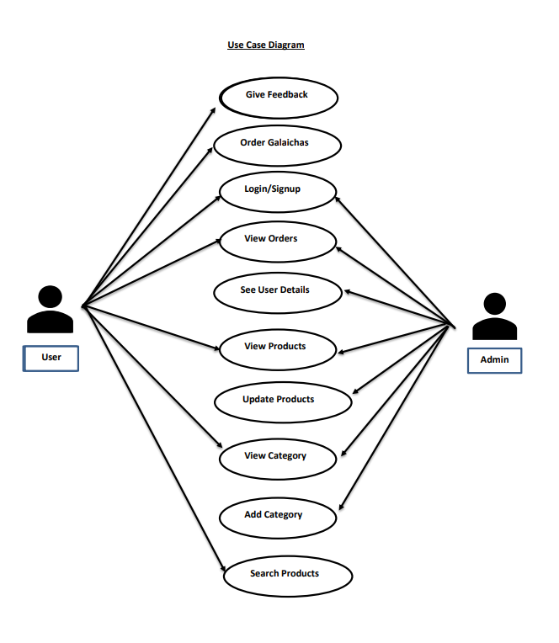

**Figure 3.1: Use Case Diagram of user and admin**

1. **Non-Functional Requirements**
   * + - **Responsive Design:** Ensure the website looks and works well on different devices and screen sizes.
       - **Speed and Performance:** The website should load quickly and respond promptly to user interactions.
       - **Security:** Implement secure user authentication and protect sensitive data.
       - **User Experience:** Provide an intuitive interface with clear navigation and visual appeal.
       - **Scalability:** The website should handle increased traffic during peak hours.

#### Feasibility Analysis

An analysis of a proposed project or system's viability from a practical standpoint is called a feasibility study. The following components are included in a study to determine whether this system is feasible.

1. **Technical Feasibility**

To assess the technical feasibility of a software development project, one should consider factors such as technical requirements, skill level, resource availability, time frame, and potential risks. By evaluating these factors, one can determine whether the project can be successfully implemented from a technical standpoint.

* + - * **Infrastructure Assessment**: Evaluating the technical infrastructure needed to support Galaicha Nepal is vital. This includes assessing web desigining, database management, and security measures to ensure compatibility and scalability.
      * **Resource Availability:** Being a two man project, it is expected that the resource available is not enough to develop the system to commercial standard in this project. Time limitation is especially a hurdle. But the system can be expected to be developed
      * **Skill level:** Selecting the right technology stack is essential for Galaicha Nepal's success.

1. **Operational Feasibility**

* User Acceptance Testing (UAT): Conducting UAT allows us to evaluate the usability and functionality of Galaicha Nepal from end-users' perspectives. Gathering feedback from stakeholders helps identify any usability issues and ensures a smooth user experience.
* Training and Support: Providing comprehensive training and ongoing support is essential for Galaicha Nepal's success. By equipping administrators and users with the necessary tools and resources, we can ensure smooth platform adoption and operation.
* Scalability and Maintenance: Assessing the scalability of Galaicha Nepal is crucial for accommodating future growth. Implementing robust maintenance procedures ensures the platform remains operational, secure, and adaptable to changing market dynamics.

1. **Economic Analysis**

From an economic standpoint, the analysis assesses the financial viability, weighing development and maintenance costs against potential revenue streams. Being developed in PHP, is economically viable as it provides a cost-effective solution without the burden of expensive proprietary software licenses. Being open-source, it minimizes upfront development costs and allows ongoing customization without additional licensing fees.

1. **Schedule Analysis**

* **Project Timeline:** Creating a realistic project timeline is essential for Galaicha Nepal's success. By outlining key milestones, deliverables, and deadlines, we can ensure efficient project management and resource allocation.
* **Critical Path Analysis**: Identifying the critical path,the sequence of tasks that determine the project's minimum duration is crucial.
  + 1. **Data Modeling (ER diagram)**

An Entity-Relationship (ER) diagram is a visual representation used in database design to illustrate the logical structure of a database. It depicts entities (objects or concepts), attributes (properties of entities), and relationships (connections between entities). ER diagrams help in understanding how different elements of a database interact and provide a blueprint for designing databases with clarity and efficiency.

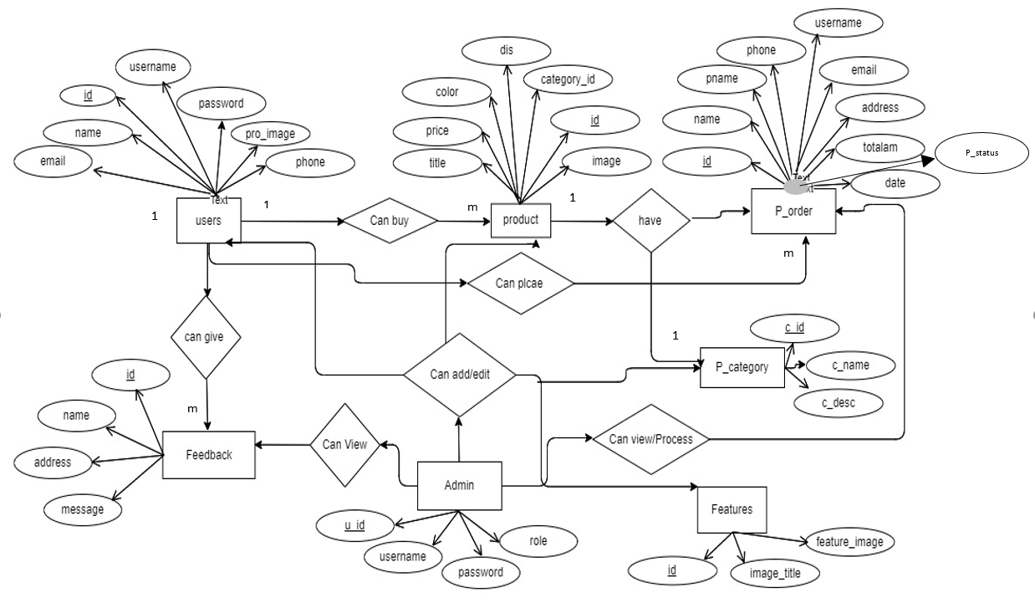

**Figure 3.2: ER-Diagram**

* + 1. **Process Modeling (DFD)**

DFD stands for "Data Flow Diagram." It's a visual representation used in software engineering and systems analysis to depict the flow of data within a system or process. DFDs illustrate how data moves between various components or processes, helping to understand system functionality, data interactions, and relationships. They are commonly used to model and document the information flow in a clear and concise manner.

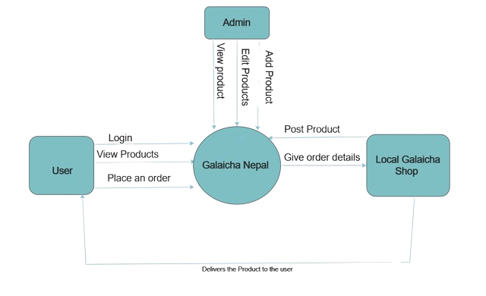

**Figure 3.3: DFD Level 0**

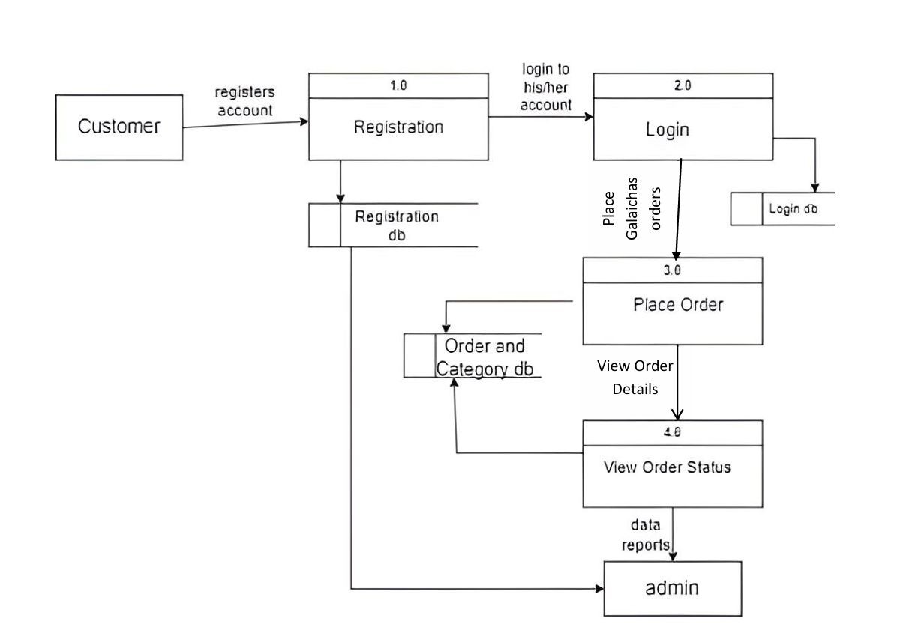

**Figure 3.4: DFD Level 1**

### System Design

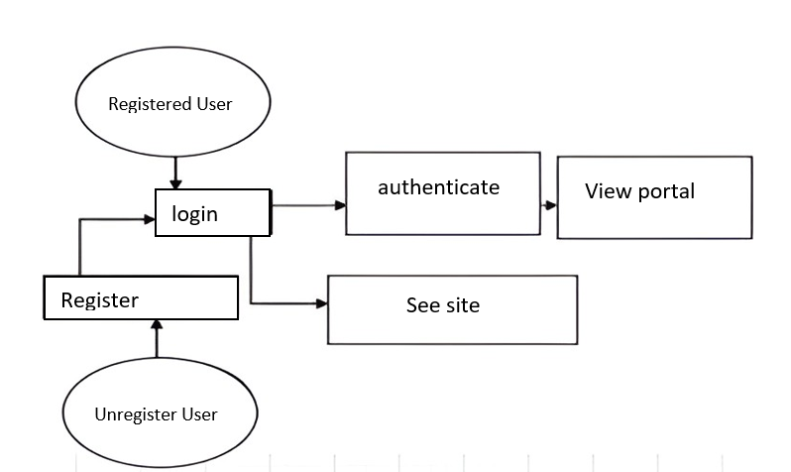

**Figure 3.5: System Design**

#### Architectural Design

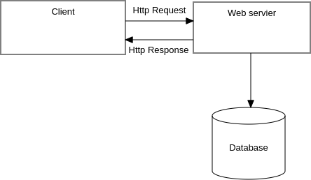

Web Server

**Figure 3.6: Architectural Design**

1. **Client-Side (Frontend):** The client-side architecture uses HTML, CSS, and JavaScript for effective presentation and user interactivity. HTML structures the web content, CSS manages layout and styling, while JavaScript handles dynamic content and enhances the user experience.
2. **Server-Side (Backend):** PHP is used as the server-side scripting language responsible for processing user requests and generating dynamic content. It manages user sessions, handles form submissions, and communicates with the MySQL database for data retrieval and updates. It is also used for crucial business logic, including order processing and user authentication.
3. **Database Server-Side:** The MySQL relational database is employed for efficient data storage and retrieval. SQL queries ensure optimized database operations, and normalization techniques maintain data integrity. The database stores information related to users, Galaichas , categories, and orders.

#### Database Schema Design

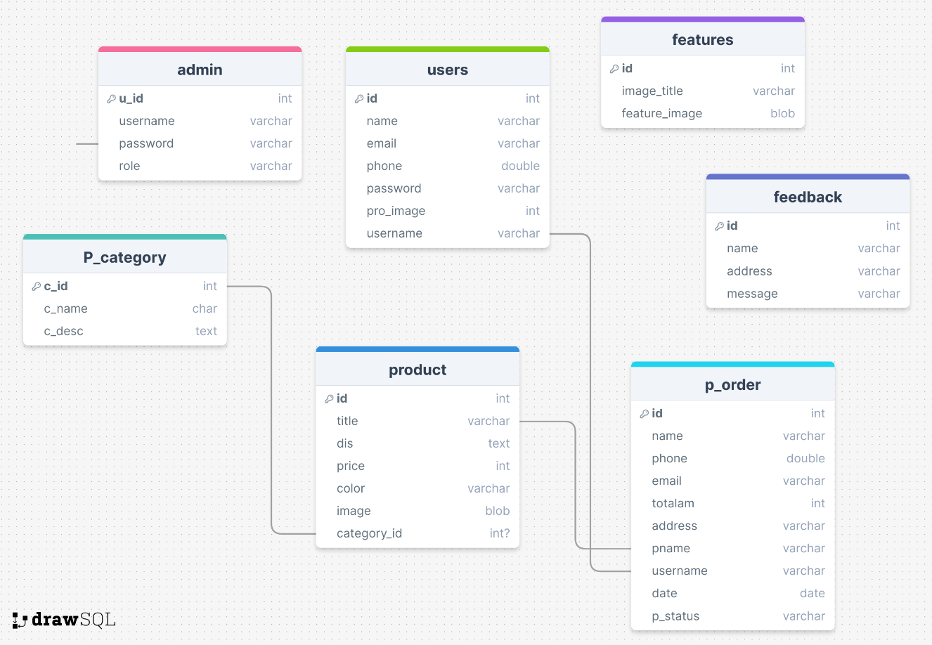

**Figure 3.7: Database Schema Design**

#### Physical DFD

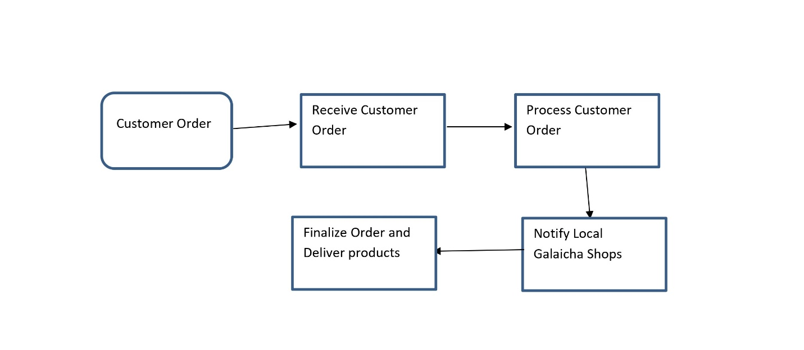

**Figure 3.8: Physical DFD**

## Chapter 4: Implementation and Testing

### Implementation

This program makes use of MySQL as its database management system. MySQL is a database management system that is popular all over the world and is frequently integrated into web applications like the one being discussed and used in the system. This system consists of a number of distinct panels, such as an administration panel, a login portal for users, page to view menu and place order and a platform for viewing bills and change order. Interfaces are what are utilized to connect each of these distinct modules to one another. Whole system is implemented using xampp server as production server and a test was carried out in xampp as well.

#### Tools Used

The Galaicha Nepal E-commerce Platform leverages a cutting-edge technology stack:

1. **Case Tools:**

* **Visual Paradigm:** Utilized for system design, modeling, and documentation, Visual Paradigm played a pivotal role in creating comprehensive visual representations within the report. It facilitated the illustration of system architecture, use cases, and data models, contributing to a clear and concise understanding of the proposed online Galaichaorder website.
* **Visual Studio Code:** Integrated as a case tool for code editing and version control, Visual Studio Code provided a robust development environment for writing and managing code. Its role in facilitating collaboration among developers and ensuring an organized development process was emphasized in the report.

1. **Programming Languages:**

* **HTML (Hypertext Markup Language):** Integral to the frontend development, HTML was employed for structuring web content and defining the layout. This language ensured the proper presentation of information on the user interface.
* **CSS (Cascading Style Sheets):** CSS was utilized extensively for styling and presentation, ensuring a visually appealing and consistent user interface across the website. It contributed to a seamless and aesthetically pleasing user experience.
* **JS (JavaScript):** JavaScript played a crucial role in implementing client-side interactivity, dynamic content updates, and asynchronous communication with the server. Its functionalities were highlighted in the payment feasibility section, emphasizing its contribution to user experience enhancement.
* **PHP (Hypertext Preprocessor):** As the chosen server-side scripting language, PHP was instrumental in processing user requests, managing server logic, and interacting with the MySQL database. The report underscored its significance in ensuring the seamless functioning of the backend operations.
* **SQL (Structured Query Language):** SQL, specifically used with MySQL, was employed for defining and manipulating the database. The report detailed its role in data storage and retrieval, emphasizing its importance in maintaining a robust and organized data structure.
* **J Query + AJAX :** used for document traversing from frontend to backend to maintain a flow of data in shopping carts.

1. **Database Platforms:**

* **MySQL:** Serving as the database platform, MySQL played a critical role in storing and retrieving data related to users, orders, and Galaichaitems. The report highlighted its reliability, scalability, and ease of integration, emphasizing its role in ensuring efficient data management for the online .

#### Implementation Details of Modules

1. **User Authentication Module:**
   * **Description**: This module manages user authentication and authorization.
   * **Procedures/Functions:**
     + registerUser(id, password, name ,phone, username, pro_image email): Registers a new user with the system.
     + loginUser(username, password): Authenticates a user and generates a session token.
     + logoutUser(userId): Logs out a user, invalidating the session token.
2. **Galaichas Display Module:**
   * **Description:** Responsible for displaying Galaichas items and categories to users.
   * **Procedures/Functions:**
     + getGalaichaCategories(): Retrieves a list of available galaichas categories.
     + searchGalaichaItems(keyword): Searches for galaichas items based on a user-provided keyword.
3. **Order Placement Module:**
   * **Description:** Manages the process of placing and processing galaichas orders.
   * **Procedures/Functions:**
     + placeOrder(id, p_name, email, Product_Id, customerName, customerContact, deliveryAddress, totalamount ): Places a new order for a user.
4. **Order Processing Module:**
   * **Description:** Handles the backend processing of orders, including updating order status.
   * **Procedures/Functions:**
     + completeOrder(orderId): Marks an order as completed upon successful delivery.
5. **Admin Dashboard Module:**
   * **Description:** Provides administrators with tools to manage users, products, and orders.
   * **Procedures/Functions:**
     + viewUserDetails: Retrieves details of a specific user for administration.
     + updateGalaichaItem(product_Id, newDetails): Allows administrators to update details of a product/Galaichas.
     + viewOrders(): Displays a list of all orders for administration purposes.

### Testing

The process of evaluating the functionality, performance, and security is referred as testing, The system is put through this process to ensure that it complies with the requirements that were outlined and it’s free of any flaws. Manual testing was used primarily as a method of testing.

* + 1. **Test Cases for Unit Testing**

Unit testing is a method that checks the functionality of separate parts or units of a software program to ensure that they perform as intended. Unit testing is utilized to test individual components of a system, such as the user interface, the database, and the application server, when it comes to the context of a Galaicha Nepal E-commerce Platform.

1. **User Authentication**

**Table 4.1 : User Authentication Test**

|  |  |  |  |
| --- | --- | --- | --- |
| **SN** | **Test Topic** | **Input /Steps** | **Expected Output** |
| 1 | User Registration | Valid user details (fullname, username, phone number , email, local address, password, picture | New user registered successfully. |
| 2 | User Login | Valid username and password. | User successfully authenticated, and a session token is generated. |
| 3 | User Logout | User ID | User logged out successfully, and the session token is invalidated. |

1. **Galaichas Display Module:**

**Table 4.2 : Galaichas Display Module Test**

|  |  |  |  |
| --- | --- | --- | --- |
| **SN** | **Test Topic** | **Input /Steps** | **Expected Output** |
| 1 | Search Galaicha Categories | Keywords | List of available Galaichas categories is retrieved. |
| 2 | Get Galaicha Categories | Click on “Products” | List of available Galaichas categories is retrieved |

1. **Order Placement**

**Table 4.3 order placement module test**

|  |  |  |  |
| --- | --- | --- | --- |
| **SN** | **Test Topic** | **Input /Steps** | **Expected Output** |
| 1 | Place Order | fullname , email , phone number , address. | New order is placed successfully |
| 2 | Get Order Details | Visit Profile | Details of the specified order are retrieved. |

1. **Admin Dashboard**

**Table 4.4 : Admin Dashboard Module Test**

|  |  |  |  |
| --- | --- | --- | --- |
| **SN** | **Test Topic** | **Input /Steps** | **Expected Output** |
| 1 | **View User Details** | Visit “Users” on Admin dashboard | Details of the specified user are retrieved. |
| 2 | **Update Galaichas Item** | Visit “Product” on Admin Dashboard and click “Update” | Galaichas item details are updated successfully. |
| 3 | **View Orders** | Go to “order” on Admin Dashboard | List of all orders is retrieved. |

#### Test Cases for System Testing

System Testing is performed with the intention of ensuring that the entirety of the system functions as intended and that it satisfies all of the requirements that were outlined during the design phase of the project. This includes testing the system's ability to process complicated transactions, deal with high volumes of traffic, and produce accurate results from calculations. In addition, the system's scalability and reliability are examined to guarantee that it will be able to support an increasing number of users over the course of time.

1. **End-to-End Order Placement:**

**Table 4.5 End-to-End Order Placement test**

|  |  |  |  |
| --- | --- | --- | --- |
| **SN** | **Title** | **Steps / Inputs** | **Expected Output** |
| 1 | User Places an Order | 1. User logs in. 2. User selects Galaicha items and adds them to the cart. 3. User provides delivery details and places the order. | Order is placed successfully, and the user receives an order confirmation. |
| 2 | Admin Views the Order | 1. Admin logs in to the admin dashboard. 2. Admin navigates to the orders section. | The admin sees the newly placed order in the list of orders to be processed. |
| 3 | Admin Processes and Completes the Order | Admin marks the order as completed after delivery. | Order status is updated to "Delivered" |

1. **User Authentication:**

**Table 4.6 : User Authentication test for system testing**

|  |  |  |  |
| --- | --- | --- | --- |
| **SN** | **Title** | **Steps / Inputs** | **Expected Output** |
| 1 | User Logs In and Logs Out | 1. User logs in with valid credentials. 2. User performs actions within the system. 3. User logs out. | User successfully logs in, performs actions, and logs out without session issues |

## Chapter 5. Conclusion and Future Recommendation

### Lesson Learnt/Outcome

The development and implementation of the Galaicha Nepal E-commerce Platform provided valuable lessons and outcomes that contribute to future project success and improvement. Some key lessons learned from our project:

* + 1. **User-Centric Design is Crucial:** Prioritizing a user-friendly interface and seamless user experience is crucial. The success of the website heavily relies on how easily users can place orders, and make payments. Regular usability testing and gathering user feedback are essential for continuous improvement.
    2. **Scalability Should be Anticipated:** The demand for the Galaicha E-commerce Website may grow over time. Anticipating scalability needs, both in terms of user traffic and data volume, is critical. A scalable architecture and infrastructure should be in place to accommodate increased usage without compromising performance.
    3. **Continuous Testing and Quality Assurance:** Rigorous testing, including unit testing, integration testing, and system testing, is essential to identify and address bugs and issues early in the development process.

### Conclusion

The Galaicha Nepal E-commerce Platform endeavors to redefine the Galaicha landscape by introducing a pioneering digital platform that connects customers with authentic Galaicha suppliers seamlessly. By harnessing cutting-edge technologies, enhancing user experiences, and empowering both customers and administrators, Galaicha Nepal is dedicated to enhancing efficiency, convenience, and overall performance within the Galaicha market. This project embodies a concerted endeavor to transform the Galaicha shopping experience, with the ultimate aim of ensuring that each purchase results in a delightful journey for customers. This study delves into the opportunities and challenges of Galaicha e-commerce in Nepal's evolving digital landscape. It provides insights into consumer behavior, technological advancements, and market dynamics, offering valuable recommendations for Galaicha Nepal's strategic development.[10]

### Future recommendations

* + 1. **Advanced Personalization:** Leverage machine learning algorithms and data analytics to enhance user personalization. By tailoring recommendations based on user preferences and behavior, the platform can provide a more engaging and personalized experience, fostering increased customer loyalty.
    2. **Mobile App Support:** Thapa and Rai's research examines the adoption and satisfaction levels of mobile technologies in Galaicha retail. By analyzing user behaviors and preferences, the study sheds light on the effectiveness of mobile platforms in enhancing the Galaicha shopping experience, informing Galaicha Nepal's mobile strategy[9]. Develop a dedicated mobile application to cater to the growing mobile user base. A mobile app offers a more convenient and responsive experience, expanding accessibility and potentially attracting a broader user demographic.
    3. **Real-Time Tracking and Notifications Enhancement:** Improve real-time order tracking features and provide proactive notifications to users. Enhancing transparency regarding order status, estimated delivery times, and promotions contributes to a more satisfactory user experience.
    4. **Loyalty Program Implementation:** Introduce a customer loyalty program to incentivize repeat business. Rewarding users for frequent orders, referrals, or participation in promotional events can foster customer loyalty and contribute to long-term success.

# REFERENCES

1. . Gurung, B., et al. (2021). "Consumer Preferences and Purchasing Behavior in the Nepali Mattress Market." Journal of Consumer Studies, 30(4), 212-225.
2. Rai, A., et al. (2018). "Technological Innovations and Market Disruptions: Implications for Galaicha E-commerce in Nepal." International Journal of Innovation Management, 25(1), 34-48.
3. Thapa, P., et al. (2017). "Challenges of Digital Transformation in Nepali Retail: Lessons for Galaicha E-commerce." Journal of Retail Management, 20(2), 89-104.
4. Sharma, S., et al. (2019). "E-commerce Trends in Nepal: Opportunities and Challenges." International Journal of Business Management, 15(3), 78-92.
5. Shakya, R., et al. (2016). "Digital Commerce Adoption in Nepal: Implications for Galaicha E-commerce." Journal of Business and Technology, 18(1), 56-70.
6. Joshi, A., et al. (2018). "Innovative Technologies and Galaicha E-commerce: A Case Study of Nepali Retailers." Journal of Innovation Management, 22(4), 112-125.
7. Khadka, N., et al. (2015). "Adoption of E-commerce in Nepal: Insights for Galaicha Retailers." International Journal of Retailing, 12(3), 78-91.
8. Bhandari, S., et al. (2020). "Cultural Significance and Market Potential of Galaicha in Nepal." Journal of Cultural Heritage Management, 10(2), 145-160.
9. Thapa, N., & Rai, A. (2022). "Harnessing Mobile Technologies for Galaicha Retail: A Case Study of User Adoption and Satisfaction." International Journal of Mobile Commerce, 15(3), 145-160.

# [10]Gurung, S., & Tamang, R. (2023). "Exploring the Digital Landscape: Opportunities and Challenges for Galaicha E-commerce

# APPENDICES

# 

**Figure : Home page**

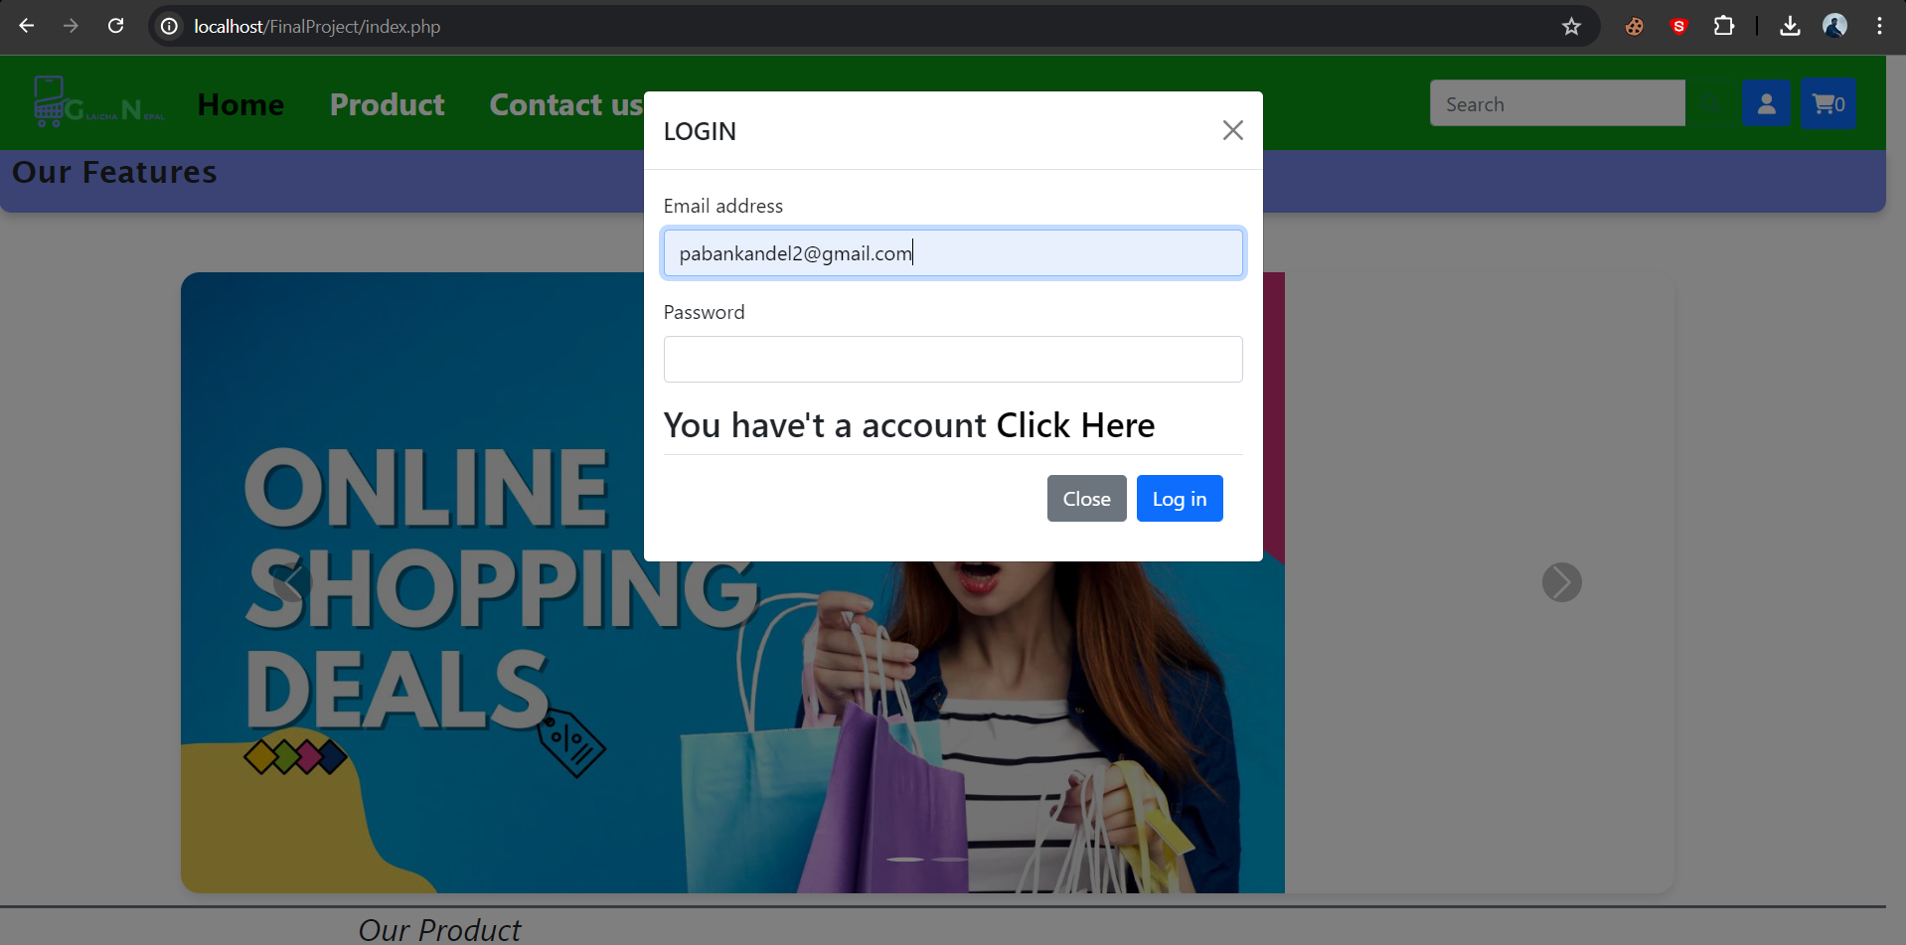

**Figure : Login Page**

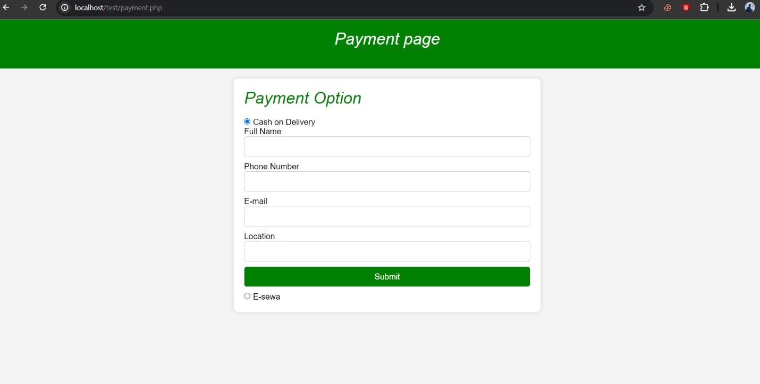

**Figure : Order Form**

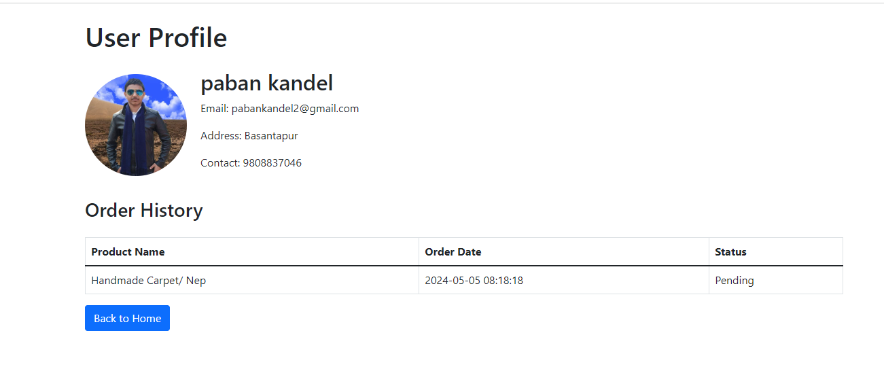

**Figure: My Orders**

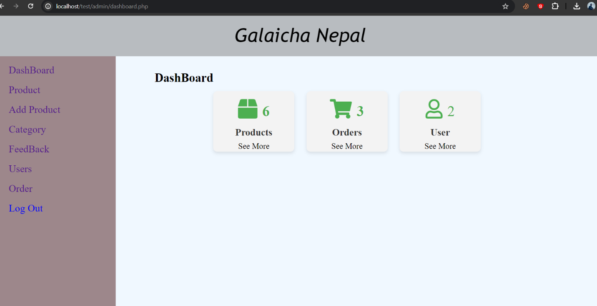

**Figure : Admin Dashboard page**

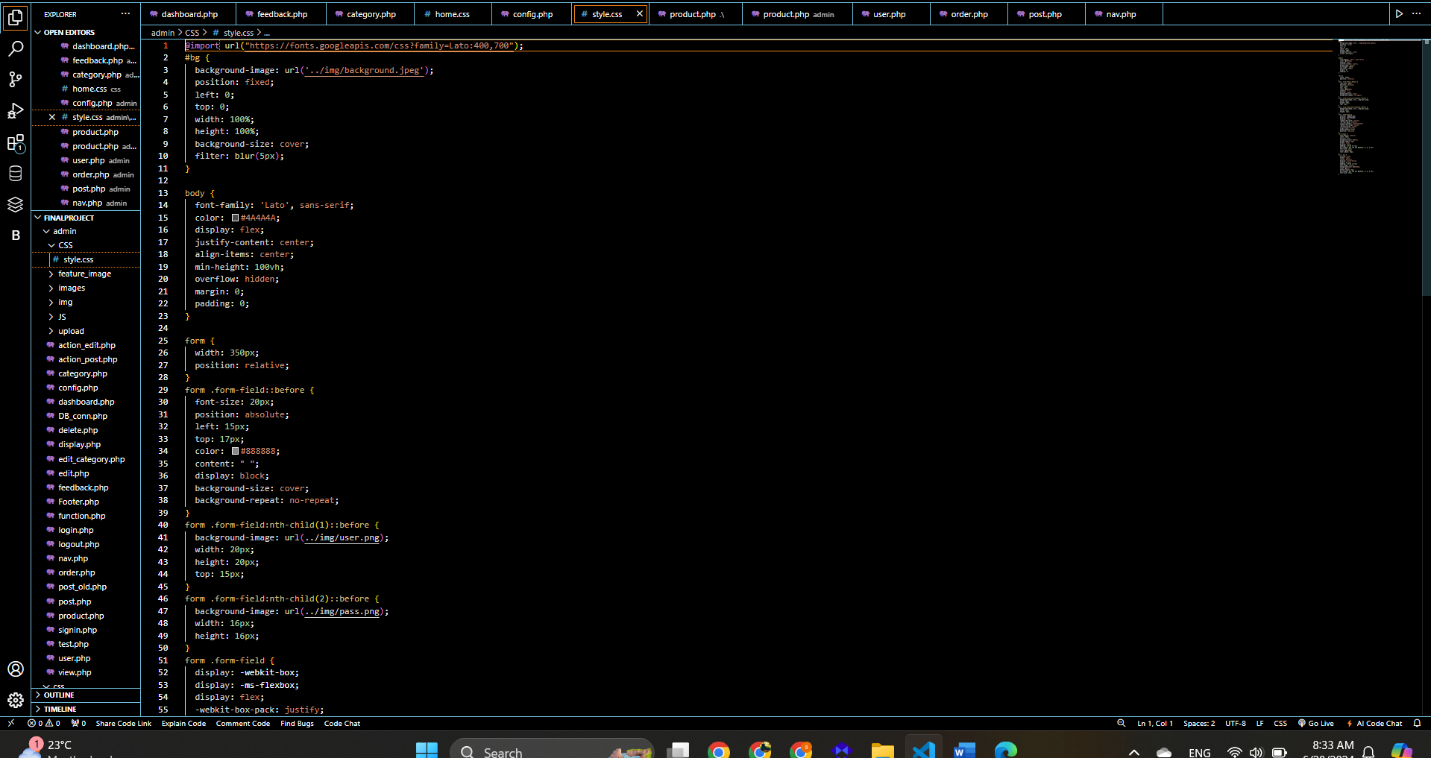

**Source code: Style.css**

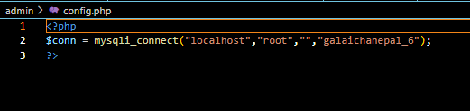

**Source code: Config.php**

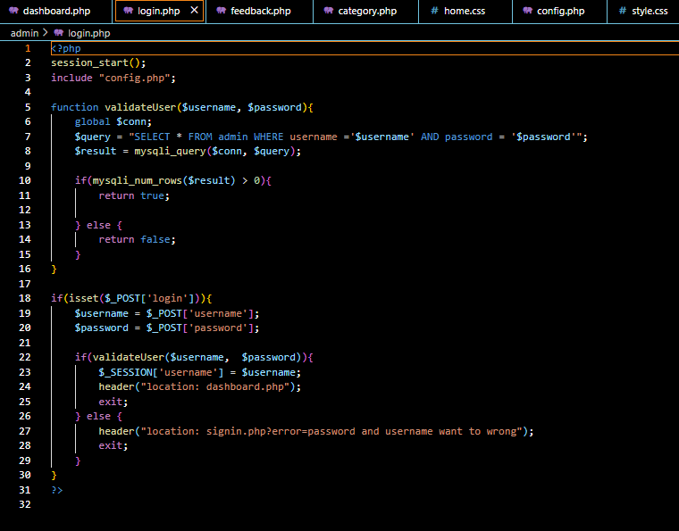

**Source code: Login.php**

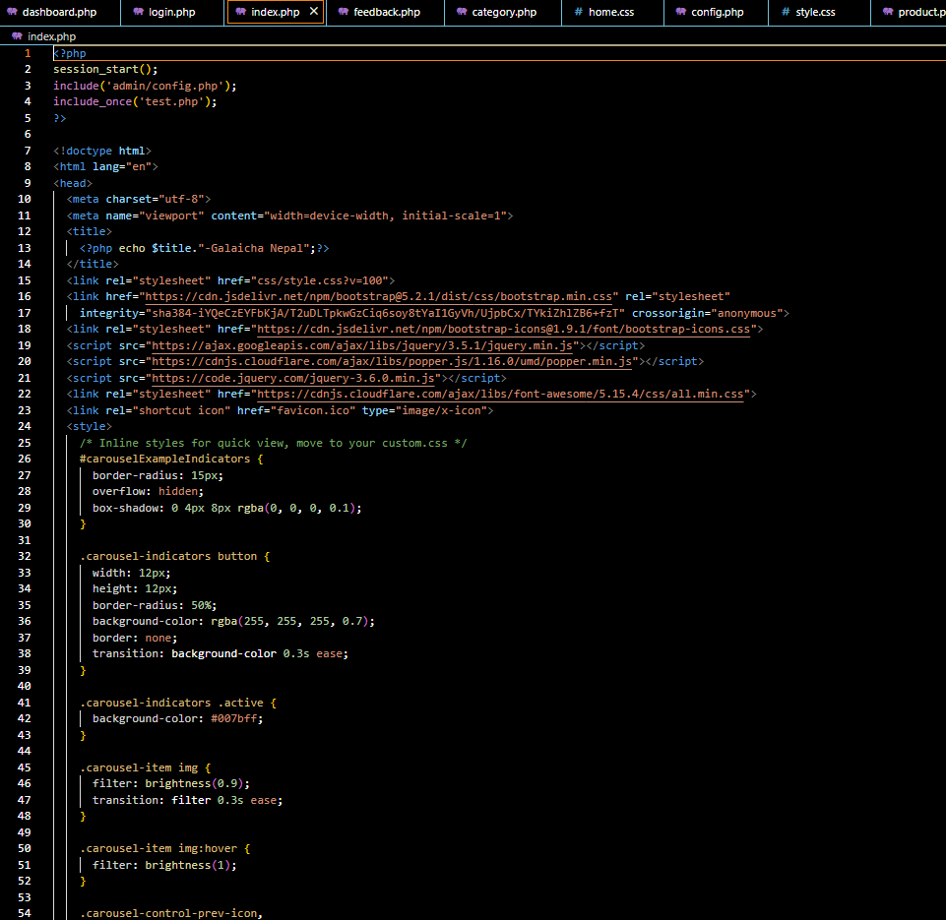

**Source code : Index.php**

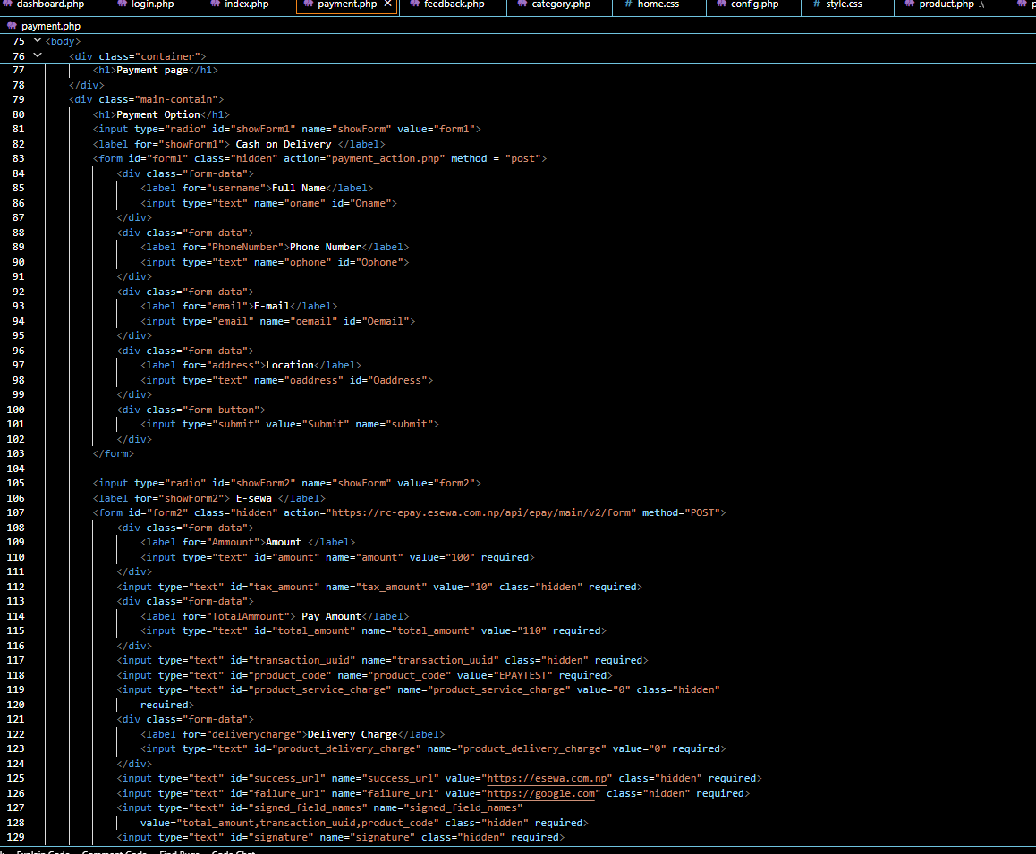

**Source code:Payment.php**

<?php

include "nav.php";

?>

<style>

/* Move styles to an external CSS file for better organization */

.main-container {

width: 70%;

margin-left: 25%;

margin-top: -50%; /* Adjust margin top */

display: flex;

justify-content: space-around;

align-items: center;

padding: 20px;

}

.main-container .container {

width: 100%;

display:flex;

}

.main-container .container .small-container {

width: 200px; /* Increase container width for better spacing */

height: 150px; /* Increase container height for better visibility */

text-align: center;

background-color: #f3f3f3; /* Lighter background color */

border-radius: 10px; /* Add border radius for rounded corners */

padding: 20px; /* Increase padding for better spacing */

margin-top:50px;

margin-right:30px;

box-shadow: 0 4px 8px rgba(0, 0, 0, 0.1); /* Add shadow for depth */

}

.small-container i {

font-size: 48px; /* Increase icon size */

margin-bottom: 20px; /* Increase margin bottom for better spacing */

color: #4CAF50; /* Green color for consistency */

}

.small-container h2 {

font-size: 24px;

color: #333;

margin-bottom: 10px; /* Increase margin bottom for better spacing */

}

.small-container span {

font-size: 36px; /* Increase font size for count */

}

.small-container a{

text-decoration:none;

color: #000;

font-size:20px;

padding-bottom:20px;

}

.small-container a:hover{

cursor: pointer;

color:red;

}

</style>

<div class="main-container">

<div class="container">

<?php

include "config.php";

$sql = "SELECT COUNT(*) AS product_count FROM product";

$result_product = mysqli_query($conn, $sql);

$sql = "SELECT COUNT(*) AS order_count FROM `p_order`"; // order is a reserved keyword, so it should be enclosed in backticks

$result_order = mysqli_query($conn, $sql);

$sql = "SELECT COUNT(*) AS user_count FROM user";

$result_user = mysqli_query($conn, $sql);

$product_count = 0;

$order_count = 0;

$user_count = 0;

if ($result_product && $result_order && $result_user) {

$row_product = mysqli_fetch_assoc($result_product);

$product_count = $row_product['product_count'];

$row_order = mysqli_fetch_assoc($result_order);

$order_count = $row_order['order_count'];

$row_user = mysqli_fetch_assoc($result_user);

$user_count = $row_user['user_count'];

}

?>

<h2>DashBoard</h2>

<div class="small-container">

<i class="fas fa-box"> <span><?php echo $product_count; ?></span></i>

<h2>Products</h2>

<a href="product.php">See More</a> <!-- Fixed the closing tag for anchor -->

</div>

<div class="small-container">

<i class="fas fa-shopping-cart"> <span><?php echo $order_count; ?></span></i>

<h2>Orders</h2>

<a href="order.php">See More</a> <!-- Fixed the closing tag for anchor -->

</div>

<div class="small-container">

<i class="far fa-user"> <span><?php echo $user_count; ?></span></i>

<h2>User</h2>

<a href="user.php">See More</a> <!-- Fixed the closing tag for anchor -->

</div>

</div>

</div>

<?php

include "Footer.php";

?>